Cntact-ID Protocolo
There are several protocols used by alarm systems to communicate with central stations. By far the most popular of them is Contact-ID. Here is the official document describing the Contact-ID standard (PDF). Like most standard documents, reading it is quite boring (though I’ve seen worse), so let me shorten the story for you:

Contact-ID Timeline
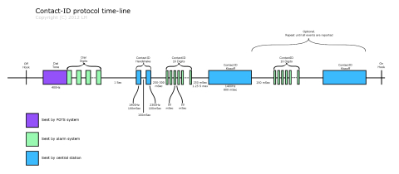
Contact-ID Protocol Time-Line
When an alarm event is triggered, the alarm system “picks up the phone” (a.k.a “takes the phone off-hook”), and waits for a dial tone. When a dial tone is received, the alarm dials the number of the central station. Up until now, we’re not dealing with the Contact-ID protocol, but simply with the necessities of using a phone line to communicate. The central station then receives the call, and waits for one second, after which it sends the Contact-ID Handshake. The handshake is made of 100 mSec of 1400Hz pure-tone, then 100 mSec of silence, and then 100 mSec of 2300Hz pure-tone. 250 mSec after that, the alarm sends the Contact-ID message. This message comprises 16 DTMF digits. Each digit is 50 mSec long, and they are separated with 50 mSec silence. The last digit is a check-sum digit that enables the central station to verify the integrity of the received message. After a successful reception of a message, the central station sends a kissoff signal. This is 800 mSec of 1400Hz pure-tone. If the alarm system does not receive the kissoff tone in time, it retransmits the message.

Contact-ID Message
The Contact-ID message contains 16 digits as follows:
- 0-3 – Account number. These four digits identify the specific alarm system or customer to the central station. These digits are not very important in Alarmino’s case, but think about a central station with thousands of customers. When it receives a call from an alarm system, it must be able to tell which one of the thousands customers is calling. These four digits enable this.
- 4-5 – Message Type. Basically this field should always be “18”. Not terribly useful, I know.
- 6 – Event Qualifier.
- 7-9 – Event Code.
- 10-11 – Group/Partition Number.
- 12-14 – Zone Number. Ahh, finely something useful. This is the number of the zone that triggered the alarm.
- 15 – Checksum.
As you can guess, Alarmino is mostly interested in the zone-number and checksum digits. It uses the checksum to verify the received message, and the zone-number to report to the user.

